**SOFTWARE REQUIREMENT SPECIFICATION**

BUS BOOKING MANAGEMENT SYSTEM

Prepared by

ASRA HAREEM

(9208)

FAIZAN RAFIQUI

(9014)

COURSE: OOAD

ASRA HAREEM(9208)

FAIZAN RAFIQUI(9014)

Course: OOAD

Proposed to

**Sir Sohail Imran**

**27-01-2020**

**Table of Contents**

Table of Contents Table of

Contents........................................................................................................................................

1.INTRODUCTION ....................................................................................................................................... 1.2.1 Challenges of the current system....................................................................................................

1.4 Justifications.......................................................................................................................................

1.5 Scope.................................................................................................................................................

1.6 Methodology......

2Audience Definitions, Acronyms and Abbreviations...........................................................................

2.1 Audience Definitions..........................................................................................................................

2.2Acronyms and Abbreviations..............................................................................................................

3.Project Features.........................................................................................................................................

3.1.Software Interfaces..............................................................................................................................

3.2 SPECIFIC REQUIREMENTS .....................................................................................................................

3.3 User Characteristics..............................................................................................................................

3.4 Apportioning of Requirements ..............................................................................................................

4. Technologies to be used..........................................................................................................................

5. Overall Description..............................................................................................................................

5.1 Product Perspective..............................................................................................................................

5.2 Product Functions.............................................................................................................................

5.3 Constraints............................................................................................................................................

5.4 Operating Environment.............................................................................................................

6. Specific Requirements...........................................................................................................................

6.1 Functional Requirements......................................................................................................................

**INTRODUCTION**

BUS BOOKING MANAGEMENT SYSTEM is aimed at reducing paper work for the bus industry and hence improving its efficiency and speeding up of all processes. The database can be accessed by the passengers from any computer terminal connected through LAN to a server where the system has been installed. Hence, all the related information about a passenger is available to Admin and Employees. Thus this software saves the entire passenger’s long queue and hassle.

* 1. **Background**

Horizon coach is a transport company Located in CBD Nairobi Kenya along Accra road. It was started in 1958. The company is most well known passenger, courier, parcel delivery and transport company operator in East Africa which provide the safest, most comfortable luxury buses on Kenyan roads today.

* 1. **Problem Statement**

In Horizon Coach, most of the driver information is kept in a file. Therefore, it is quite hard for them to search the driver information when needed. Moreover, it uses a lot of papers and data is lost because no backup provided for the data. Some of the data is quite hard to read because the form was filled up by hand writing. Other problems that occur in Bus Information is tracking its maintenance record. Most of the bus will be maintained at list four times in year. By using a manual form, each bus must have its own maintenance record file. Problems that occur to this manual system are to store the maintenance record file and to find it back. It takes quite a time in order to find the correct maintenance record needed.

* + 1. **Challenges of the current system**

**i.** Congestion of passengers in booking office leading to registration office using manual assigning of numbers which is a waste of time.

**ii**. Lack of immediate information storage –the information generated by various transactions takes time and efforts to be stored at a right file.

**iii.** Lack of prompt updating- various changes to information like passenger details are difficult to make as paper work is involved

**iv.** Inability to automatically schedule services, generate receipt and receive payments from passengers.

**v.** Being unable to update the manual records. vi. Preparation of accurate and prompt reports-this becomes a difficult task as information is difficult to collect from various books. **vii.** Inability to retain records as they are lost if they are kept on wrongly. e.g change of office file storage.

* + 1. **Proposed solution**

Horizon Coach have decided to take charge in designing a system that is friendly and will try to work out solution in a way that favors the interests of every customer and workers solve problems faster, manage data, so that all the transactions become fast.

* 1. **Objectives**

The objective of “Bus booking management system” is to easily track the information of all customers, and bus destination. The main goal of the software is to build a good management tool for all customers. The main purpose of this software is to reduce the time taken through manual system in order to maintain all the records.

**1.4 Justifications**

The purposes of this system is to help easily capture the information of all user and to reduce the time taken through manual system in order to maintain all the records

**1.5 Scope**

This system is helpful to reduce the time and complexity of maintaining the records. It also helps in accurate maintenance of passengers . -It can be used in any transport company for maintaining details.

**1.6 Methodology**

Research method Data collection methodologies Horizon coach uses a manual system but is not efficient on passenger’s detail. So I thought there was a need to improve on passenger registration system to overcome some problems.

**Data collection tools**

-I observed that their system is not efficient on keeping a passenger registration details this give the passenger a hard time if one loses receipt issued.

2. Documentation review- all the documents used to record transactions and capturing of information were available. These gave me views of what kind of data is involved in the current system to enable me borrow from it.

**2 Audience Definitions, Acronyms and Abbreviations**

**2.1 Audience Definitions**

The intended readers of this document are the developers of the site, testers, website owners, managers and coordinators.

**2.2 Acronyms and Abbreviations**

|  |  |
| --- | --- |
| **Acronym** | **Meaning** |
| BBMS | Bus Booking management system |
| C# | C#.Net MVC 5 |
| SQL | SQL Server |
| HTTP | Hypertext Transfer Protocol |

**3. Project Features**

I. Registration and management.

II. Manage bus routes

III. Manage bus detail

IV. Manage price details

**3.1 Software Interfaces**

All databases for the Bus Booking management system will be configured using My SQL 2008. These databases include Bus detail and information. These can be modified by the end users. The bus database will include the bus number plates, seats.

**3.2 SPECIFIC REQUIREMENTS**

This section contains all the software requirements in a more detailed manner, that when combined with the system context diagram, use cases, and use case descriptions, is sufficient to enable designers to design a system to satisfy those requirements, and testers to test that the system satisfies all the requirements.

**3.3 User Characteristics**

Educational level of BBMS computer software – Low

Experience of BBMS software – None

Technical Expertise – Little 3

**3.4 Apportioning of Requirements**

The audio and visual alerts will be deferred because of low importance at this time. 3.9 Assumptions and Dependencies - The system is not required to save generated reports. - Credit card payments are not included

## 4. Technologies to be used

* Programming languages:
* C#: C#.Net is a programming platform— part of the MVC 5 frameworkfor developing and running distributed multi-tier architecture web application
* HTML, XML: Hyper Text Markup Language and Extensible markup Language are the predominant markup languages for web pages. It provides a means to describe the structure of text-based information in a document and to supplement that text with interactive forms, embedded images, and other objects.

SQL Server:

Sql server is used to create Database **Tools & Development Environment**

Microsoft Visual Studio:

Microsoft Visual Studio is a toolkit which is designed for the creation of complex projects, providing fully dynamic web application.

**5. Overall Description**

**5.1 Product Perspective**

The implementation of this system will help in handling daily operation efficiently and good performance of the travelling agencies. It will improve record storage as all data will be stored in the database.

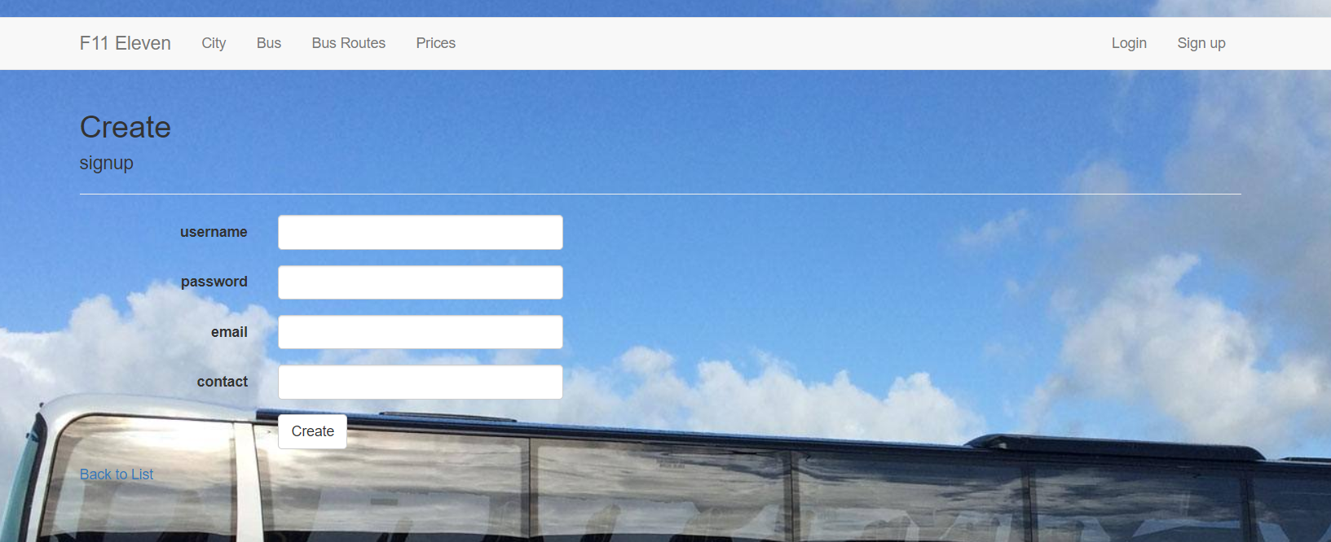

**5.2 Product Functions**

* User: Administrator
* Functions: The Administrator is the super user and has complete control over all the activities that can be performed. Control all the bus activities and route changes
* User: Customer
* Functions: A customer can see the bus timing routes and price detail

.

## 5.3 Constraints

* There is no maintainability of back up so availability will get affected.
* Limited to HTTP/HTTPS.
* No multilingual support

**5.4 Operating Environment**

The BBMS is a website that shall operate in all famous browsers And Google Chrome

**6. Specific Requirements**

**6.1 Functional Requirements**

1. **Administrator:**

* **Database Management:** Control the database and keep track of all records of user bus details routes and prices
* **View all details:** View the details of all routes and control the whole site.
* **Advertising the Site:** Responsible for making advertisements for the site.

1. **User:**

* **Login:** user must have a valid login id to enter into the site.
* **Registration:** New users can sign up by creating new ID.

**7. GUI**

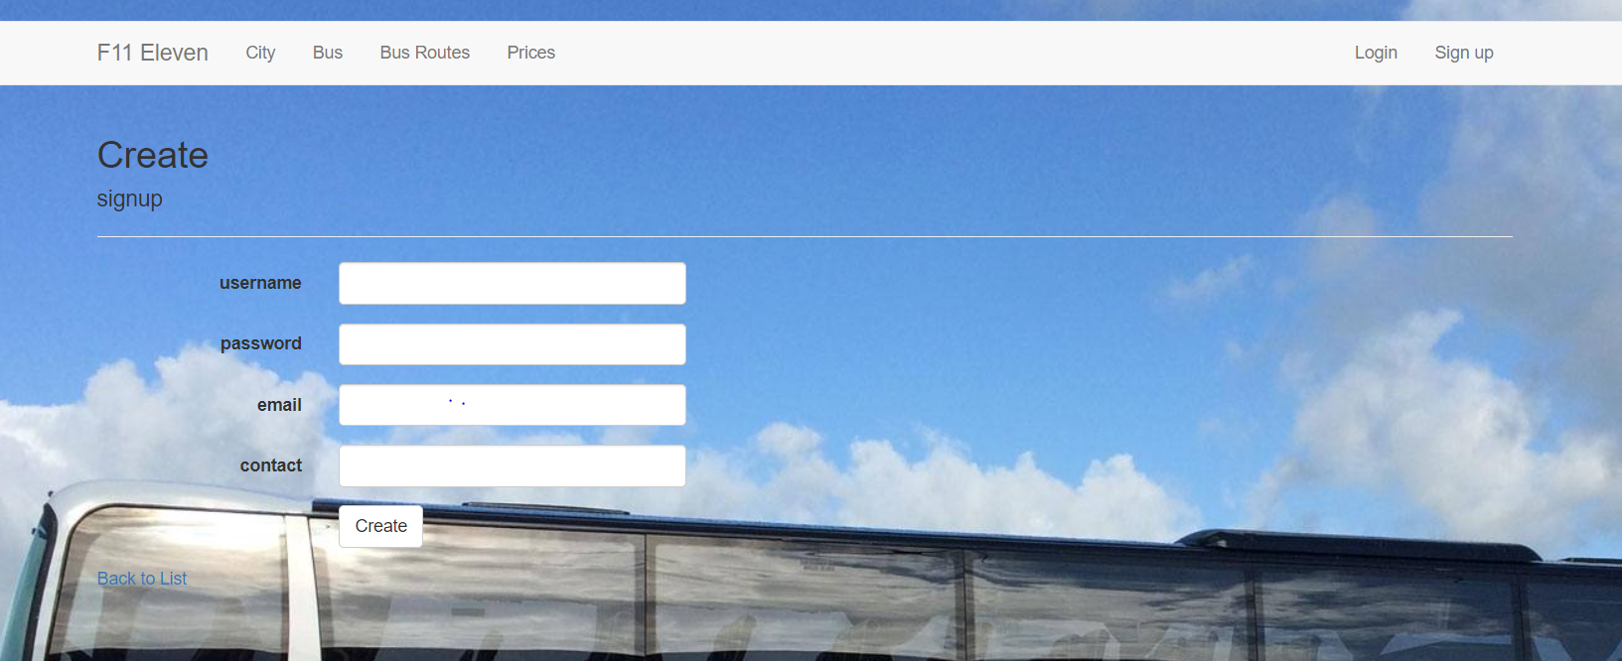

**8. DATABASE:**

**Signup:**

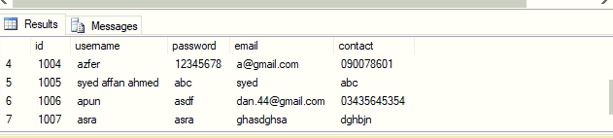

**Buses**

